# Objective: To evaluate the performance of a machine learning model in predicting prices for various crops using an extended dataset.

## Dataset:

The dataset includes:

* Crop
* Date
* Real-Time Price (Actual Price)
* Prediction (Predicted Price)
* Deviation (Difference between Real-Time and Prediction)
* %Accuracy (Accuracy of the Prediction)

## Data Overview:

The dataset covers dates for each crop with corresponding real-time and predicted prices. Data spans from 04/03/2024 to 13/03/2024 for corn, cotton, tomato, onion, and paddy, with potato data extending to 27/04/2024.

## **Analysis Approach:**

1. **Accuracy Calculation**:
   * 
   * Deviation and accuracy are computed for each crop and date.
2. **Descriptive Statistics**:
   * Average real-time price, predicted price, deviation, and accuracy percentage are calculated for each crop.

## Key Findings and Output:

1. **Corn**:
   * Average Real-Time Price: 2278.33
   * Average Predicted Price: 2740.333
   * Average Deviation: 461.9998
   * Average Accuracy: 79.722026%

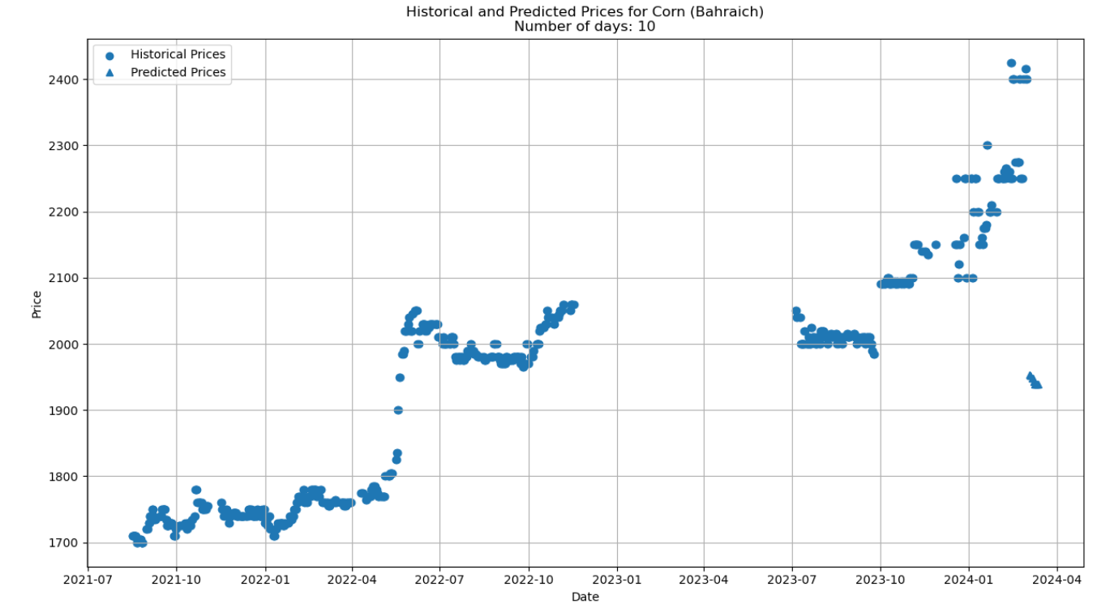

1. **Cotton**:
   * Average Real-Time Price: 7110.06
   * Average Predicted Price: 7546.396
   * Average Deviation: 436.3333
   * Average Accuracy: 93.863158%

1. **Tomato**:
   * Average Real-Time Price: 1055.00
   * Average Predicted Price: 3727.289
   * Average Deviation: 2672.289
   * Average Accuracy: -153.29758% (Poor model performance)

1. **Onion**:
   * Average Real-Time Price: 1255.56
   * Average Predicted Price: 1585.812
   * Average Deviation: 330.256
   * Average Accuracy: 73.696427%

1. **Paddy**:
   * Average Real-Time Price: 1200.00
   * Average Predicted Price: 1734.947
   * Average Deviation: 534.9474
   * Average Accuracy: 55.421046%

1. **Potato**:
   * Average Real-Time Price: 2333.33
   * Average Predicted Price: 1426.378
   * Average Deviation: 906.9593
   * Average Accuracy: 61.130316%

## Conclusion:

The model shows high accuracy for predicting cotton , corn , and paddy prices but performs poorly for tomatoes. For onions and potatoes, accuracy is moderate. This analysis highlights the model's strengths and areas for improvement.

## Visual Analysis:

The visual representation of the data (image provided) shows detailed predictions and deviations for each crop. The table in the image provides a clear overview of the model's performance across different dates and crops. This can help identify trends and patterns in prediction accuracy and highlight specific areas where the model needs adjustment.